Report
Assignment 3
1DV701

Author: Ruslan Abdulin
Email ra222rt@student.lnu.se

Author: Andrei Neagu
Email xxxx@student.lnu.se

Semester: Spring 2020

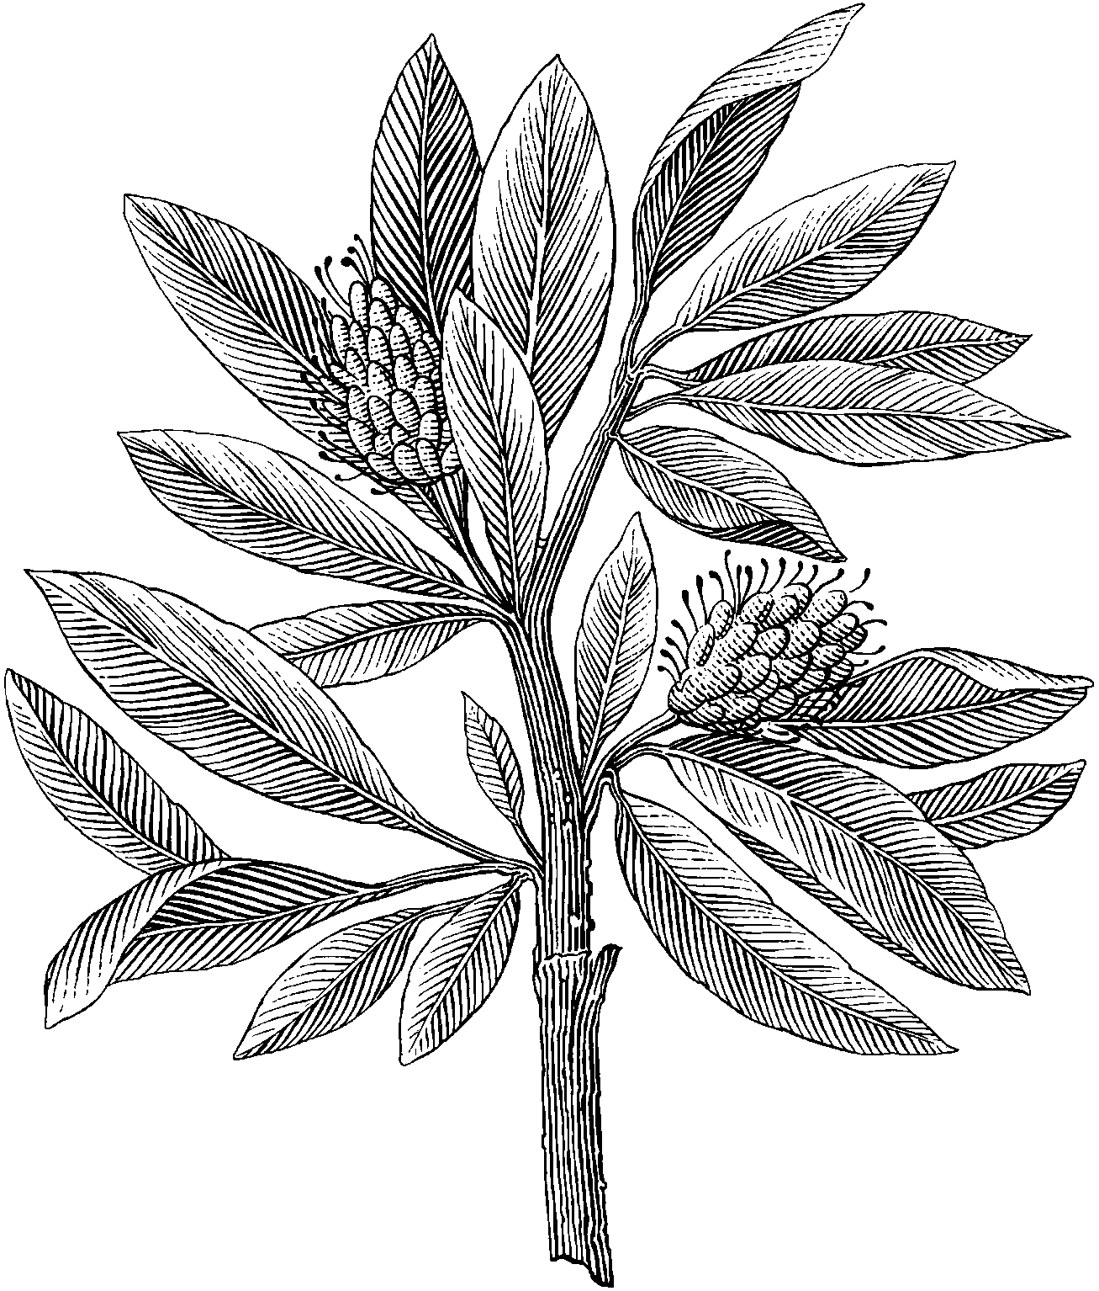

Contents
1 Problem 1 I
1.1 Discussion I
2 Problem 2 I
2.1 Discussion I
2.2 VG 1 I
2.2.1 Discussion I
3 Problem 3 I
3.1 Discussion I
3.2 VG 2 I
3.2.1 Discussion I

Problem 1
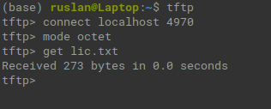

Discussion

Problem 2
Place your screenshots here

Discussion

VG 1
Place your screenshots here

Discussion

Problem 3
Place your screenshots here

Discussion

VG 2
Place your screenshots here

Discussion

